Week 13

Question 1:
Given an array of numbers, find the index of the smallest array element (the pivot), for which the sums of all elements to the left and to the right are equal. The array may not be reordered.
Input Format:
Input from stdin will be processed as follows and passed to the function.
The first line contains an integer n, the size of the array arr.
Each of the next n lines contains an integer, arr[i], where 0 ≤ i < n.

Program:
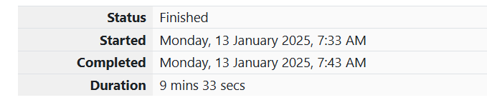
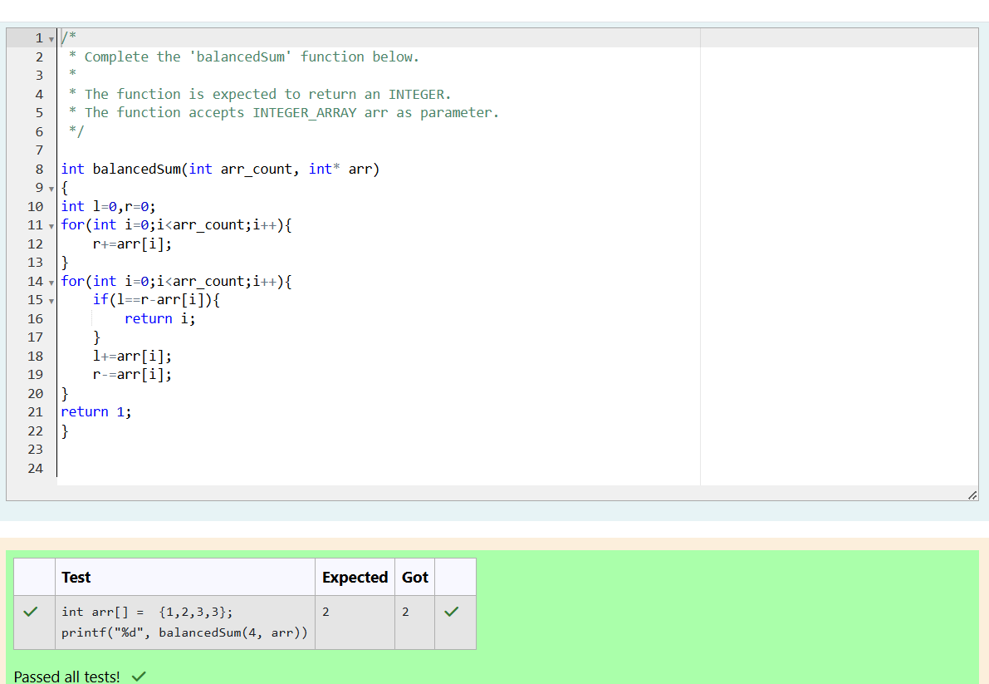

Question 2:
Calculate the sum of an array of integers.
Input Format:
Input from stdin will be processed as follows and passed to the function.
The first line contains an integer n, the size of the array numbers.
Each of the next n lines contains an integer numbers[i] where 0 ≤ i < n.

Program:


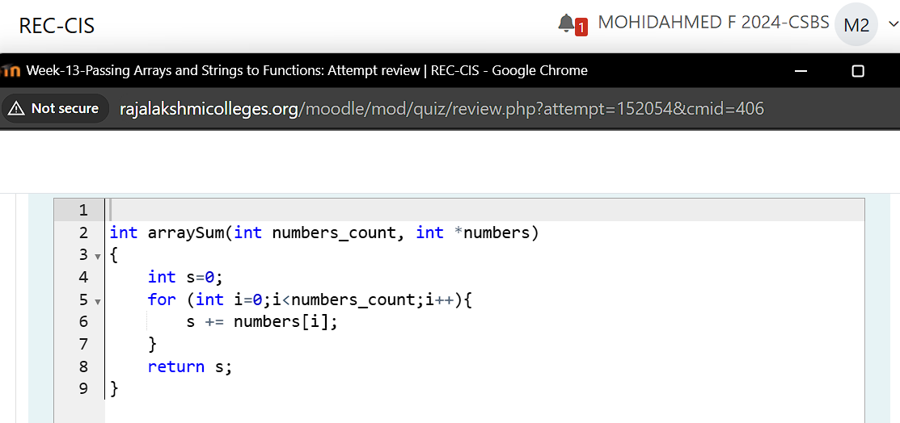
Output:
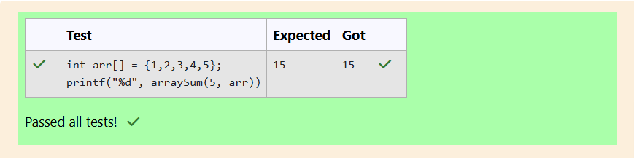

Question 3:
Given an array of n integers, rearrange them so that the sum of the absolute differences of all adjacent elements is minimized. Then, compute the sum of those absolute differences. Example n = 5 arr = [1, 3, 3, 2, 4] If the list is rearranged as arr' = [1, 2, 3, 3, 4], the absolute differences are |1 - 2| = 1, |2 - 3| = 1, |3 - 3| = 0, |3 - 4| = 1. The sum of those differences is 1 + 1 + 0 + 1 = 3.
Input Format:
The first line of input contains an integer, n, the size of arr. Each of the following n lines contains an integer that describes arr[i] (where 0 ≤ i < n) .
Program:


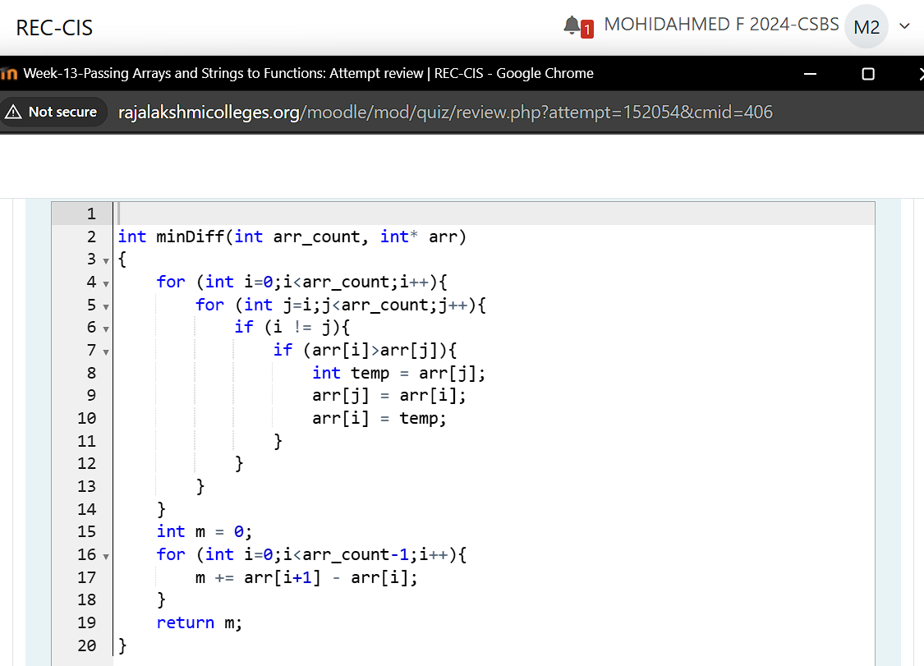
Output:
